Tanu Singh Superset ID: 6362191

Kafka Integration with C#
Codes:
KafkaConsumer.cs
<Project Sdk="Microsoft.NET.Sdk">
<PropertyGroup>
<OutputType>Exe</OutputType>
<TargetFramework>net9.0</TargetFramework>
<ImplicitUsings>enable</ImplicitUsings>
<Nullable>enable</Nullable>
</PropertyGroup>
<ItemGroup>
<PackageReference Include="Confluent.Kafka" Version="2.11.0" />
</ItemGroup>
</Project>
Program.cs
using System;
using System.Threading;
using Confluent.Kafka;
class Program
{
static void Main(string[] args)
{
var config = new ConsumerConfig
{
BootstrapServers = "localhost:9092",
GroupId = "chat-consumer-group",
AutoOffsetReset = AutoOffsetReset.Earliest
};
using var consumer = new ConsumerBuilder<Ignore, string>(config).Build();
consumer.Subscribe("chat-messages");
Console.WriteLine("🎧 Kafka Chat Consumer Started!");
Console.WriteLine("Waiting for messages... (Press Ctrl+C to exit)");
var cts = new CancellationTokenSource();
Console.CancelKeyPress += (_, e) => {
e.Cancel = true;
cts.Cancel();
};
try
{
while (!cts.Token.IsCancellationRequested)
{
try
{
var consumeResult = consumer.Consume(cts.Token);
Console.WriteLine($"📨 {consumeResult.Message.Value}");
}
catch (ConsumeException e)
{
Console.WriteLine($"❌ Consume error: {e.Error.Reason}");
}
}
}
catch (OperationCanceledException)
{
Console.WriteLine("🛑 Consumer canceled.");
}
finally
{
consumer.Close();
Console.WriteLine("✅ Consumer closed.");
}
}
}
Output:
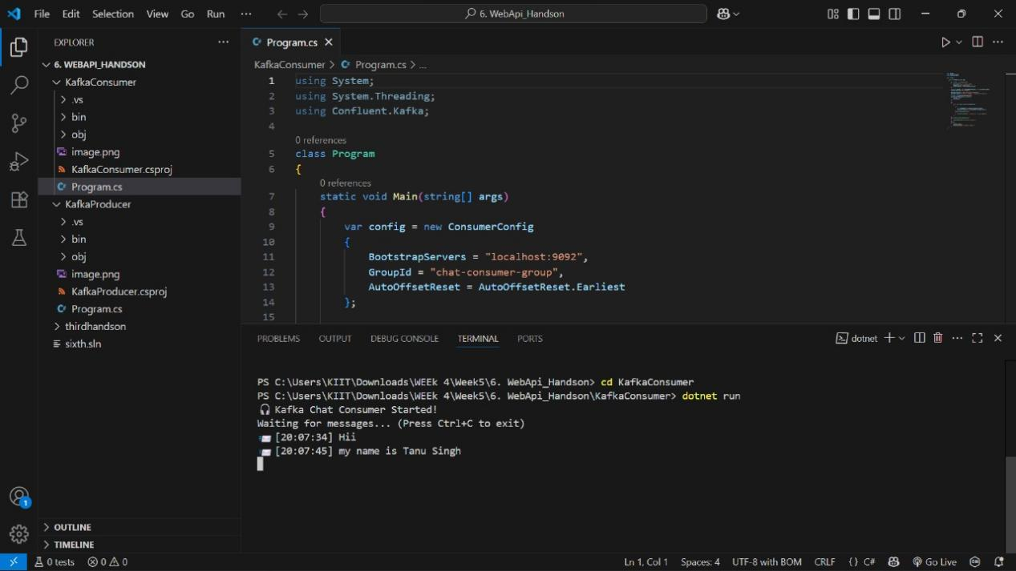

KafkaProducer.cs
<Project Sdk="Microsoft.NET.Sdk">
<PropertyGroup>
<OutputType>Exe</OutputType>
<TargetFramework>net9.0</TargetFramework>
<ImplicitUsings>enable</ImplicitUsings>
<Nullable>enable</Nullable>
</PropertyGroup>
<ItemGroup>
<PackageReference Include="Confluent.Kafka" Version="2.11.0" />
</ItemGroup>
</Project>

Program.cs
using Confluent.Kafka;
using System;
using System.Threading;
using System.Threading.Tasks;
class Program
{
private static readonly CancellationTokenSource cts = new CancellationTokenSource();
static async Task Main(string[] args)
{
Console.CancelKeyPress += (_, e) =>
{
e.Cancel = true;
cts.Cancel();
Console.WriteLine("\nShutting down...");
};
var config = new ProducerConfig
{
BootstrapServers = "localhost:9092",
EnableDeliveryReports = true,
Acks = Acks.All,
MessageTimeoutMs = 5000,
SocketTimeoutMs = 30000,
MessageSendMaxRetries = 3,
RetryBackoffMs = 1000
};
try
{
using var producer = new ProducerBuilder<Null, string>(config)
.SetLogHandler((_, logMessage) =>
{
Console.WriteLine($"[Kafka] {logMessage.Level}: {logMessage.Message}");
})
.SetErrorHandler((_, error) =>
{
Console.WriteLine($"[Kafka Error] {error.Reason}");
if (error.IsFatal) cts.Cancel();
})
.Build();
Console.WriteLine("Kafka Chat Producer Started");
Console.WriteLine("Type messages (press Ctrl+C or type 'quit' to exit):");
while (!cts.IsCancellationRequested)
{
Console.Write("You: ");
var message = await ReadLineAsync(cts.Token);
if (string.IsNullOrWhiteSpace(message)) continue;
if (message.Equals("quit", StringComparison.OrdinalIgnoreCase)) break;
var messageWithTimestamp = $"[{DateTime.Now:HH:mm:ss}] {message}";
try
{
var deliveryResult = await producer.ProduceAsync(
"chat-messages",
new Message<Null, string> { Value = messageWithTimestamp },
cts.Token
);
Console.WriteLine($"Message delivered to partition {deliveryResult.Partition}, offset {deliveryResult.Offset}");
}
catch (ProduceException<Null, string> ex)
{
Console.WriteLine($"Failed to deliver message: {ex.Error.Reason}");
}
catch (OperationCanceledException)
{
Console.WriteLine("Message delivery cancelled");
break;
}
catch (Exception ex)
{
Console.WriteLine($"Unexpected error: {ex.Message}");
}
}
}
catch (Exception ex)
{
Console.WriteLine($"Fatal error: {ex.Message}");
}
finally
{
cts.Dispose();
Console.WriteLine("Producer shut down completed");
}
}
private static async Task<string> ReadLineAsync(CancellationToken cancellationToken)
{
string input = null;
var task = Task.Run(() =>
{
input = Console.ReadLine();
}, cancellationToken);
try
{
await task;
return input;
}
catch (TaskCanceledException)
{
return string.Empty;
}
}
}
Output:
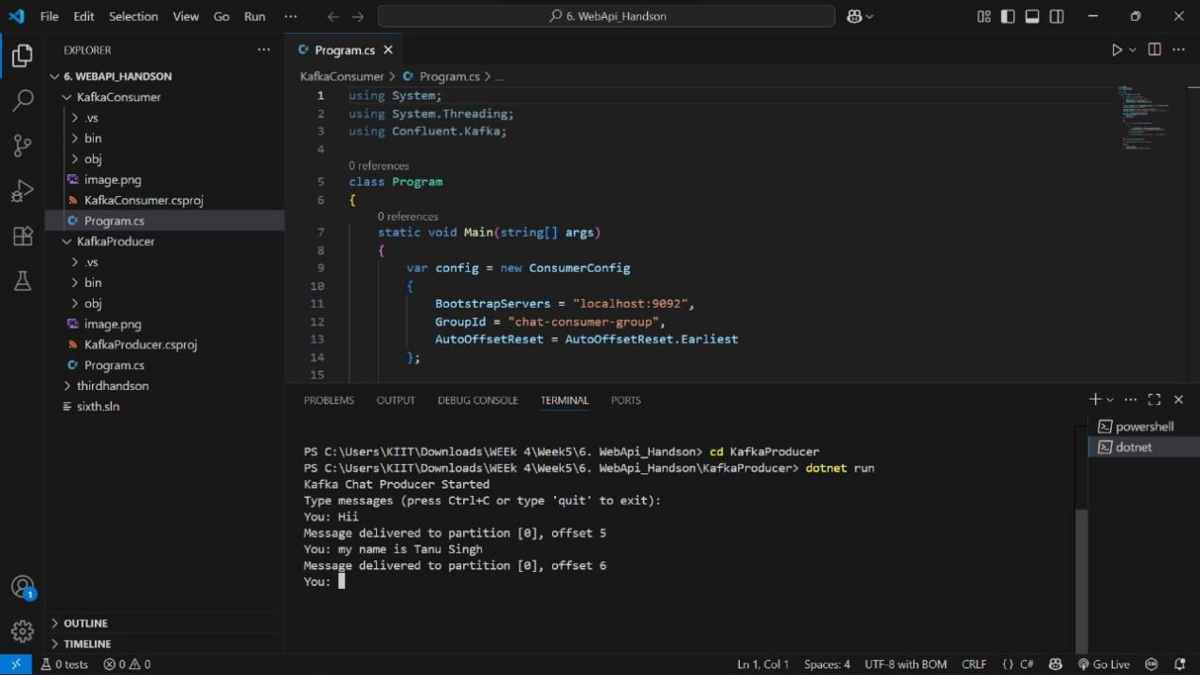

Authentication and Authorization in ASP.NET Core Web API Microservices
Codes:
fifth.cs
<Project Sdk="Microsoft.NET.Sdk.Web">
<PropertyGroup>
<TargetFramework>net9.0</TargetFramework>
<Nullable>enable</Nullable>
<ImplicitUsings>enable</ImplicitUsings>
</PropertyGroup>
<ItemGroup>
<PackageReference Include="Microsoft.AspNetCore.Authentication.JwtBearer" Version="9.0.7" />
<PackageReference Include="Microsoft.AspNetCore.Cors" Version="2.3.0" />
<PackageReference Include="Microsoft.AspNetCore.OpenApi" Version="9.0.6" />
<PackageReference Include="Swashbuckle.AspNetCore" Version="9.0.3" />
<PackageReference Include="System.IdentityModel.Tokens.Jwt" Version="8.12.1" />
</ItemGroup>
<Project>

appsettings.json
{
"Jwt": {
"Key": "YourSuperSecretKey1234567890",
"Issuer": "https://localhost:5001",
"Audience": "https://localhost:5001",
"DurationInMinutes": 30
}
}

appsettings.Development.json
{
"Logging": {
"LogLevel": {
"Default": "Information",
"Microsoft.AspNetCore": "Warning"
}
}
}
Program.cs
using Microsoft.AspNetCore.Authentication.JwtBearer;
using Microsoft.IdentityModel.Tokens;
using System.Text;
var builder = WebApplication.CreateBuilder(args);
builder.Services.AddAuthentication(JwtBearerDefaults.AuthenticationScheme)
.AddJwtBearer(options =>
{
options.TokenValidationParameters = new TokenValidationParameters
{
ValidateIssuer = true,
ValidateAudience = true,
ValidateLifetime = true,
ValidateIssuerSigningKey = true,
ValidIssuer = builder.Configuration["Jwt:Issuer"],
ValidAudience = builder.Configuration["Jwt:Audience"],
IssuerSigningKey = new SymmetricSecurityKey(
Encoding.UTF8.GetBytes(builder.Configuration["Jwt:Key"]))
};
});
builder.Services.AddAuthorization();
var app = builder.Build();
app.UseAuthentication();
app.UseAuthorization();
app.Run();

Output:
